August 19, 2020
Greetings from your Executive Director:
In the August 11 newsletter, we presented polling data that indicates among all the divisive and sensationalized coverage of everything right now, most people “get it” and want thoughtful reform, not slashed budgets and “abolishment” of law enforcement. The polling also showed people seem to filter and factor for the bias and narratives created for them by the media, social media, and politicians.
Want to see a great example? Just last week, Gallup published a poll of Americans confidence in U.S. institutions. Take a look at the graph below which provides a stark overview. Check out the group at the top and the group at the bottom:
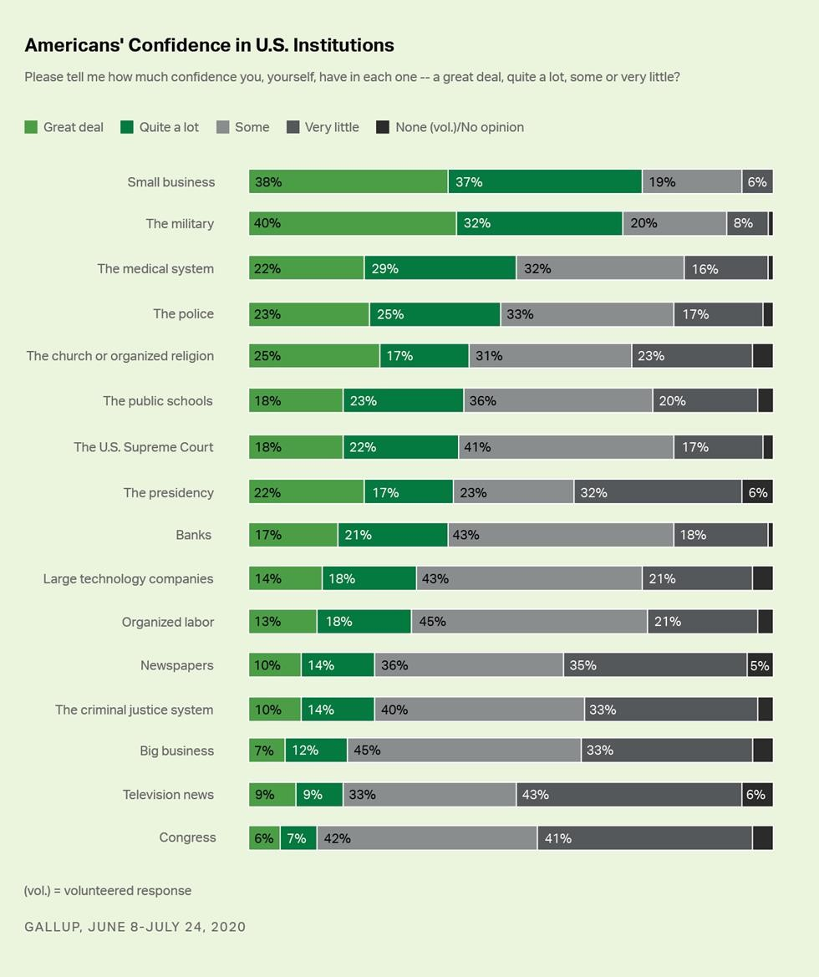
By a large margin, “the police” are near the top, just below small business, the military, and the medical system. (We must acknowledge, however, that these look different based on race and age.) At the same time, look at the very bottom of the graph: Newspapers, television news and Congress have very, very low confidence by those polled. Only 24% of respondents had a “great deal” or a “quite a lot” of confidence in newspapers, while the police had 48% by the same criteria. 40% of respondents said they had “very little” or “no confidence” in newspapers, and TV news was even worse- 49%.
The big takeaway they wanted you to see was “About 48% of Americans said they have a "great deal" or "quite a lot" of confidence in police, down from 53% the previous year and an all-time high of 64% in 2004”. The article does not mention results for newspapers or TV news.
It is also very notable that “the criminal justice system” ranked much, much lower than “the police”. This provides good support for looking at those additional elements of the system as well. A poll in California this past week also shows that through all the rhetoric, people see the need for balance. In the poll, there is support for reforms, but also very strong support for their local departments. This confirms what we are seeing all over our state.
Almost every community in our state and in our nation see that support for thoughtful reform and support for law enforcement are not mutually exclusive. The federal government is not going to solve this, the media and social media certainly aren’t going to improve anything, and it is up to our local communities.
While some local elected leaders are reacting to social media, we see most communities are engaging in good and thoughtful discussions. Seattle’s budget cuts are being rightly criticized and it is being pointed out that there is no plan. As former Chief O’Toole says in this article, “I just think this council sadly has resorted to sound bites and knee-jerk reactions and lost a police chief as a result.”
Here are a few other links about this same issue.- the shortsighted reaction from Seattle has brought a strong response from a lot of stakeholders:
U.S. Mayors’ Group Opposes Police Defunding Efforts While Urging Reform
The Seattle City Council owes Police Chief Best an apology
Seattle chief’s departure highlights council failure
6 steps to real, enduring police reform
Police Chief’s decision to quit may have just saved Seattle from itself
Tacoma and Pierce County must learn from Seattle’s ‘defund the police’ fiasco
Police reform starts with close look at budget
Our Capitol Hill store was looted, the collateral damage of a lack of leadership
I have spoken with several Sheriffs and Chiefs, some of whom have already begun background processes for Seattle officers looking to go to different departments. The theme I keep hearing, time and again, is that Seattle PD is losing some of the very people the community needs most right now. This is a real tragedy for that department and for that city. Interim Chief Diaz is doing great work, and we all continue to offer him any support he may need.
Chief Rod Covey has submitted his resignation from the WASPC Board due to being on administrative leave and the lengthy timeframe for resolution. While he is confident the process will find he did nothing wrong, Chief Covey has indicated since it has already gone on for several months, he wanted Chief Meidl to be able to appoint a replacement. Chief Meidl has subsequently appointed Kent Chief Rafael Padilla to the unexpired position on the Board. Congratulations Chief Padilla and thank you for being willing to serve!
We will also need a new Police Chief Co-Chair for the WASPC Training Committee to serve alongside Co-Chair Sheriff Drew Hyer. If you are interested please let me know and thanks.
You may have seen this, but here is a link to a new report on School Safety recently issued by the COPS Office- FYI.
Finally, here is a great story about a food bank truck that was stolen in Fife- kudos to the officers who handled the original call and who helped recover it! The response to the victim of the theft was typical of law enforcement and their spirit of service.
Thanks and stay safe!
Steven D. Strachan, Executive Director
Washington Association of Sheriffs & Police Chiefs

