March 29, 2022
Greetings from your Executive Director:

First and foremost, our thoughts are with the Everett Police Department, the Pierce County Sheriff’s Office, and the Edmonds Police Department as each mourns officers lost recently. We will pass along memorial and other information as we receive it and plans are finalized.

Just having to list three separate agencies having suffered these unimaginable losses in such a short time is numbing. I know many are feeling raw and exhausted, as are the teams you lead. We keep taking hit after hit, and you are each there to step up and continue to be “the rock”, leading and managing through all of it. At the same time, your communities are very concerned about public safety and the effects of rising crime, and the effects on neighborhoods, businesses, and trust in government. Please know it is acknowledged and appreciated. Here is another reminder from me to you: take care of yourselves, and make sure you monitor how you are doing while you take care of your agencies and communities. I mean it.

The 2022 legislative session ended on March 10 and I’d like to share an assessment on where we are, big picture, regarding public safety policy overall.

During the 2022 session, WASPC focused on fixing four key areas of the 2021 reform laws:
- .50 caliber “military equipment”
- When physical force is authorized
- Definition of physical force
- Vehicular Pursuits
Thankfully, the .50 caliber “military equipment” proposal was quickly agreed-to and passed without conflict or fanfare via HB 1719 Washington State Legislature, and is now enacted law.

The Legislature chose to use two different pieces of legislation to address when physical force is authorized – HB 1735 Washington State Legislature and HB 2037 Washington State Legislature. HB 1735 (ITAs, court orders, community caretaking, etc.) was passed without major objection. This bill passed the Legislature and is now enacted law, though it relies on the definition of “physical force” in HB 2037 to be fully operational.

HB 2037 passed the Legislature and was signed into law, but not without significant opposition. HB 2037 defines physical force and allows officers to use physical force to prevent a person from fleeing a lawful detention (Terry stop). Legislators and advocates alike claimed HB 2037 will “reverse last year’s progress on racial justice, while doing little to provide public safety for Washingtonians.” It is notable that many of the same legislators who voted for the problematic bills last session did vote for these necessary changes, and acknowledged the issues created by the original bills.

A Closer look at Pursuits (SB 5919)
SB 5919, which dealt with vehicular pursuits, fell victim to legislative gamesmanship and did not pass the Legislature. WASPC sought legislation to replace the de facto ban on vehicular pursuits with a framework that allowed vehicular pursuits only for criminal offenses where the offense was more dangerous than the pursuit. If the pursuit ever became more dangerous than the offense, the pursuit must be terminated. This, ironically, is pretty much the same ‘balancing test’ that legislators use to inaccurately describe the current law.

Simply put, the current law allows and encourages a brazen contempt for the law, and as many of you see every day, criminals believe they can simply drive away and law enforcement can’t do much to stop them. Unfortunately, they’re right. We feel strongly that fleeing in a vehicle should not be a get-out-of-jail-free card.

Both chambers passed versions of SB 5919 with strong majorities. The Senate passed SB 5919 as a ‘balancing test’ proposed by WASPC with a bipartisan 31-18 vote. The House passed a narrowed version, replacing the balancing test and simply lowering the current the probable cause standard down to reasonable suspicion, by a bipartisan 86-12 vote.

A number of newspapers around the state published this article pointing out the overwhelming vote in both chambers and assuming it would become law, as most reasonable and sensible observers would logically do.

While both chambers passed SB 5919, since the House passed it with different language, the bill needed the Senate to “concur” with the House amendments in order to send the bill to the Governor’s desk. The Senate majority leadership chose to not allow the bill to be voted on and the bill died when session ended.

The Senate’s deliberate inaction on SB 5919 was not without effort. There were at least three different motions made on the Senate floor to bring SB 5919 up for a vote, and Senators – many of them who voted yes on SB 5919 when it first passed the Senate – voted against allowing the Senate to consider the bill.

When asked why the Senate did not concur with the bill on the last day, Senate leaders mentioned “it didn't have the votes.” It is troubling that a bill with no less than 31 confirmed yes votes “didn’t have the votes” to pass.

As always, WASPC has focused on paying attention to the details, raising objections when necessary, providing specific ways to address them, and always offering balanced solutions. Some criticize us for fighting too hard, pointing out the unintended consequences, and identifying problems with the “sweeping” reform laws. In discussing our approach with our Board, our Legislative Committee, as well as many Sheriffs and Chiefs, we believe the foundational elements of law enforcement that allow us to serve victims and the public are worth it, and would do it again.
Now what?

Everyone agrees that law enforcement should work to de-escalate when possible, team up and slow down, and put the sanctity of human life at the center of every encounter with the public. Many are also now beginning to agree that we need public safety. However, it requires resources, training, and supervision to “team up”. We also need the tools to hire good people, ensure accountability, and provide clear, supportive direction so officers know what is expected of them.
The number of use of force incidents each year is largely determined by contacts and arrests, and how frequently suspects confront, flee, and resist. Recent law changes have had the effect, both intended and unintended, of broadly removing law enforcement from many situations, and reducing any kind of proactive policing. The result? Predictably, fewer contacts, fewer arrests, fewer uses of force. The downside? Fewer crimes averted, fewer criminals held accountable and more concern for public safety. Last week Amazon moved employees away from a planned re-start of in-person employees in the office in Seattle not because of the pandemic, but because of crime. Just this week we have seen multiple pot shop robberies and shootings.

We need to separate lawful and constitutional use of force from excessive and unnecessary force, build and maintain balanced and transparent systems to show the difference, and communicate that difference. When you add that to the elements of de-escalation, you get what Chief Scairpon in Marysville talks about: Team Up, Slow Down, Tell Our Story.

Instead, policy makers in our state have:

- emboldened criminals and allowed a continuing environment of brazen disregard for the law,
- reduced or eliminated consequences for those who victimize others,
- discouraged arrests even when it is clearly justified and needed, and
- ignored and minimized crime and concerns over public safety.

These trends have made it more difficult to retain and attract the people we need, which only exacerbates the problem. Our state must do the heavy lifting to invest and support behavioral health and treatment, ensure consistent consequences for endangering others, and create an environment for accountable, well trained, well-staffed law enforcement who know what is expected, know what happens if they do it wrong, and feel supported. This takes cooperation, commitment and talking to each other. It takes bipartisan leadership, which we saw for a while this session, until we didn’t.

WASPC proposed legislation for the 2021 session to require the state to establish accountable state investments in social services, treatment, and other programs that are shown to reduce the likelihood of future involvement in the criminal justice system. In other words, help people who need help before the cops have to get involved. That proposal was never taken up. Why, you wonder? Because it was proposed by the cops. We know that because that’s what legislators told us. The public is tired of the name-calling, dueling narratives, and partisanship that do not provide for balanced approaches to public safety, and do not increase public trust.

In all of this, we, as law enforcement leaders, need to continue to do our part-- provide strong leadership, stay consistent and reliable, and focus on public safety. We also need to reinforce leaders who do the hard work to create the right balance.

Moving forward, please keep an eye on the environment of contempt for the law, the frequency of people fleeing lawful traffic stops, and the consequences of the current pursuit restrictions, particularly in the context of the legislature’s decision to make no changes to the law. Most agencies already have very restrictive pursuit policies, because no one wants pursuits to occur, but this current law has created an unintended but dangerous change in the environment for criminals. We are seeing the sometimes tragic results. Here is some recent coverage of this issue:
Here are the most recent auto theft numbers, through the end of February, still showing all-time highs, at well over 4000 per month.

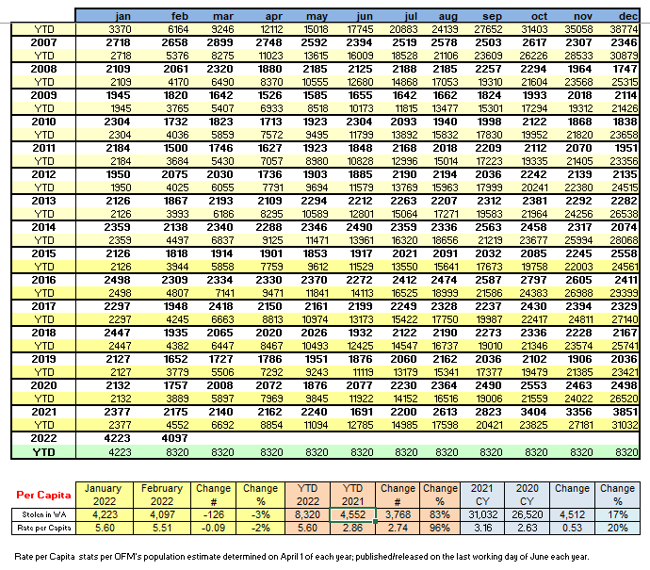

KING 5 did this story about the alarming rise in car thefts. The environment of brazen behavior of criminals is highlighted in this article from Mountlake Terrace, where Chief Caw confirmed for me their experience in seeing more and more of these types of incidents.
Federal Way Chief Andy Hwang penned this letter to the editor highlighting his concerns in his community. Gig Harbor Chief Kelly Busey commented on the gaps in law this week and the problems it will continue to create.
KUOW did this story the legislative changes and our concerns with gaps in the “fixes”.
Here is WASPC’s post-session statement.

…And finally

With the recent passage of HB 1701, which increases pension benefits, there are some of you considering, or who have decided, to soon retire. You should do what is right for you and for your family. You also need to hear that I recently gave a talk to a civic group in my community, and when I began to discuss rises in crime, I was struck by the body language and the attention from the audience, many of whom wanted to share their own recent experiences with being victims of crime. The concern is very real and very widespread. There is real appreciation for good law enforcement and your leadership in your community. Despite all the challenges, good people doing good work matters, especially now. I am honored to be able to work with each of you, and thank you for what you do every day.
I will leave you with a quote I know you have seen before, but I encourage you to read it again. Amend the gender-specific language and it means just as much today as it did over a hundred years ago:
“It is not the critic who counts; not the man who points out how the strong man stumbles, or where the doer of deeds could have done them better. The credit belongs to the man who is actually in the arena, whose face is marred by dust and sweat and blood; who strives valiantly; who errs, who comes short again and again, because there is no effort without error and shortcoming; but who does actually strive to do the deeds; who knows great enthusiasms, the great devotions; who spends himself in a worthy cause; who at the best knows in the end the triumph of high achievement, and who at the worst, if he fails, at least fails while daring greatly, so that his place shall never be with those cold and timid souls who neither know victory nor defeat.”
-Theodore Roosevelt

Stay Safe- Steve

Steven D. Strachan, Executive Director
Washington Association of Sheriffs & Police Chiefs
3060 Willamette Drive NE
Lacey, WA 98516
steve@waspc.org
360-486-2380

Executive Assistant: Rachelle Harwood
rharwood@waspc.org

